

**ONLINE SHOP**

**Software Design Document**

– Hanoi, May 2022 –

**Table of Contents**

I. Overview 3

1. Code Packages 3

2. Database Schema 4

II. Code Designs 6

1. Class Diagram 6

2. Class Specifications 6

III. Database Tables 9

1. <Table name 1> 9

2. <Table name 2…> 9

# I. Overview

## 1. Code Packages/Namespaces

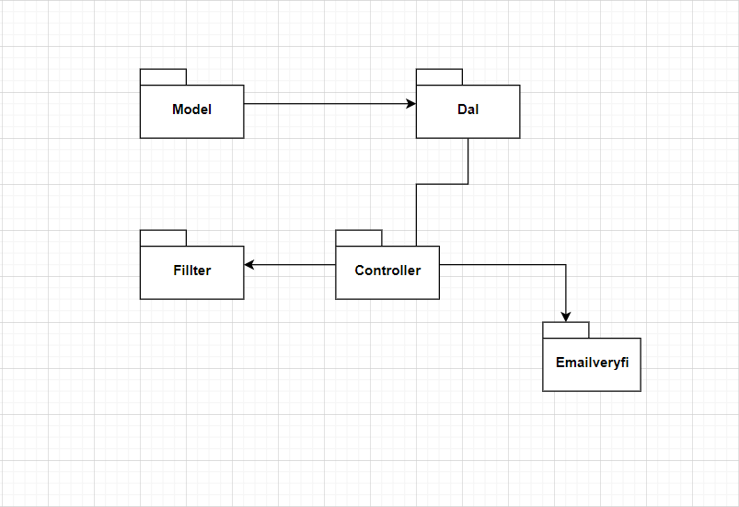

***Package descriptions & package class naming conventions***

|  |  |  |
| --- | --- | --- |
| **No** | **Package** | **Description** |
| 01 | Model | Contains objects |
| 02 | Controller | Connect to the server and execute the logic, for example: Sliders List , Products List , User Profile , Users List , Change Password , Customers List , Product Details , Customer Details , Orders List |
| 03 | Dal | Execute logic, execute sql statement to get data from database , for example : Add , edit , delete …. |
| 04 | Filter | Used for login |
| 05 | Emailveryfile | Verify email address while entering account |

## 2. Database Schema

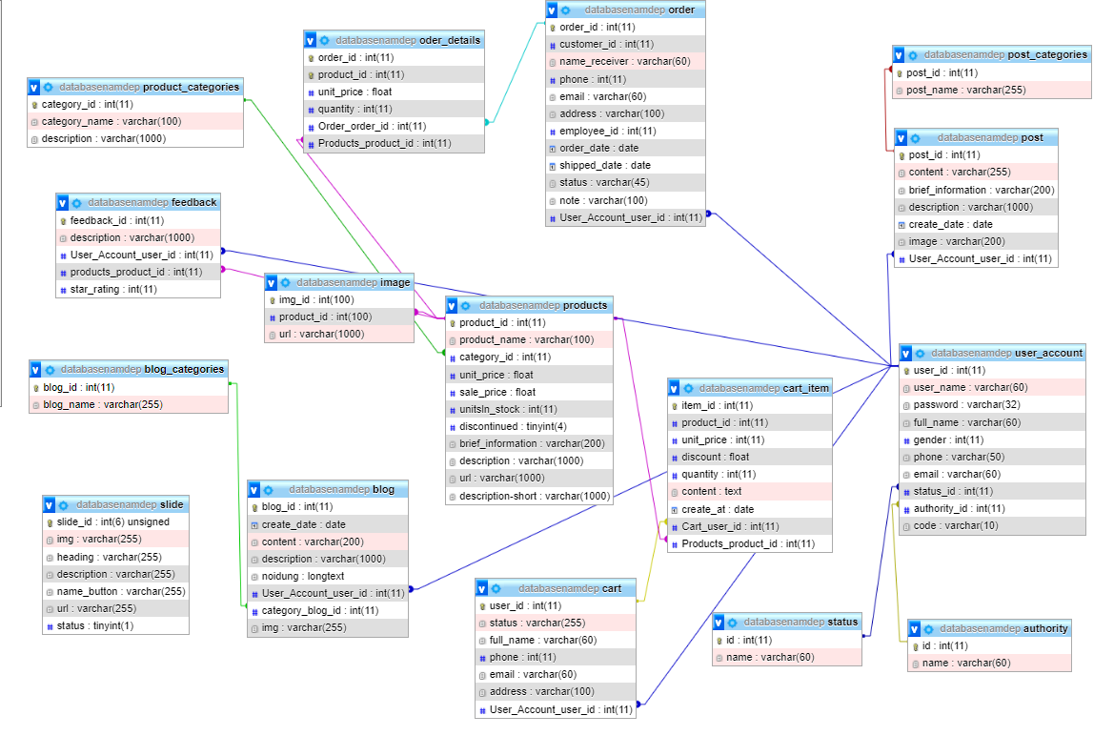

***Table descriptions & package class naming conventions are as below***

|  |  |  |
| --- | --- | --- |
| **No** | **Table** | **Description** |
| 01 | authority | - Primary keys: id |
| 02 | blog | - Primary keys: blog_id  - Foreign keys: category_blog_id  - Foreign keys: User_Account_user_id |
| 03 | blog_categories | - Primary keys: order_id |
| 04 | cart | - Primary keys: user_id  - Foreign keys: User_Account_user_id |
| 05 | cart_item | - Primary keys: user_id  - Foreign keys: Cart_user_id  - Foreign keys: Products_product_id |
| 06 | feedback | - Primary keys: feedback_id  - Foreign keys: User_Account_user_id  - Foreign keys: products_product_id |
| 07 | image | - Primary keys: img_id  - Foreign keys: product_id |
| 08 | order_detail | - Primary keys: order_id  - Foreign keys: Order_order_id, Products_product_id |
| 09 | order | - Primary keys: order_id  - Foreign keys: User_Account_user_id |
| 10 | post | - Primary keys: post_id  - Foreign keys: User_Account_user_id |
| 11 | post_categories | - Primary keys: post_id  - Foreign keys: post_id |
| 12 | product | - Primary keys: product_id  - Foreign keys: category_id |
| 13 | product_categories | - Primary keys: category_id |
| 14 | slide | - Primary keys: slide_id |
| 15 | status | - Primary keys: id |
| 16 | user_account | - Primary keys: user_id  - Foreign keys: status_id , authority_id |

# II. Code Designs

### 1. Class Diagram

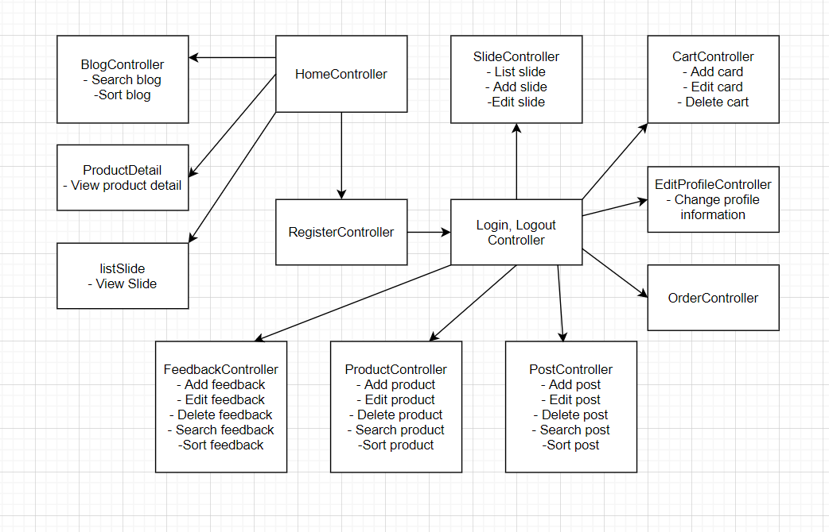

### 2. Class Specifications

***Class Methods***

|  |  |
| --- | --- |
| Home controller | Shows slider , hot posts , products  - Shown slider information includes its image and title the user is redirected to the slider's backlink on his/her clicking  - Shown post information includes its thumbnail, title, brief-info. The user is redirected to the post's details on his/her clicking  - Shown product information includes its thumbnail, title, brief information. The user is redirected to the product's details on his/her clicking |
| Register controller | This is a pop-up screen which allows the user to register himself/herself to the system by input following information: full name, gender, email, mobile, and address; User then need to verify by clicking the link sent via email to him/her before being able to access the system |
| Login, log out controller | This is a pop-up screen which allows the user to enter email & password to login; on this page, there are also options for user to register new information or reset the password for the case he/she forget it |
| Blog controller | Show the posts pagination (sorted by updated date, paginated) + the slide with the post search box, post categories, the latest posts, and static contacts/links; Shown post information includes its thumbnail, title, brief-info; the user is redirected to the post's details on his/her clicking |
| Product detail | Show product details (including title, category, images, original price, sale price, and product details) + the sider with the product search box, product categories, the latest products, and static contacts/links |
| List slide | Show detailed slider information (image, title, backlink, status, notes) |
| Slide controller | Show the paginated list of sliders (including sliders' id, title, image, backlink, status)  - The user can filter the sliders by the status + search by title or backlink  - For each slider, the user can choose to hide, show, edit it |
| Cart controller | Show the cart details with list of the user's chosen products (including Id, title, price, quantity, total cost) and the total order price + the sider with the product search box, product categories, the latest products, and static contacts/links; The user can  - Change the quantity of each product: the total cost is automatically adjusted  - Choose to delete/remove product by clicking on the deleting icon  - Click the Choose More Product button to go to Products List page  - Click the Check Out button to go to the Cart Contact page  Please note: the user's chosen products from the last browsing session remain in his/her cart until he/she submits the cart. However, the product prices are updated with the latest prices in the system |
| Edit profile controller | This is a pop-up screen which allows the user to edit his/her profile information, including the registered ones & the avatar image. Please note that s/he is not allowed to change the email |
| Order controller | Show the order details, including the following information:  - Basic order information: order id, customer full name, email, mobile, order date, total cost, sale name, status  - The receiver information: full name, gender, email, mobile, address  - This list of ordered products, each product include following information: thumbnail, name, category, unit price, quantity, total cost |
| Post controller | Show detailed post information (thumbnail, category, title, brief information, description, flag to turn the featurning on/off, status), from that allow the user to input, view or edit them |
| Product controller | Show the paginated list of products (include products' id, thumbnail, title, category, list price, sale price, featured, and status information):  - The user can filter the product by category, status or search by title, brief info  - Sortable by title, category, list price, sale price, featured, or status  - From each product, the user can choose to hide, show, view, edit it  - The page also have the button/link that allows the user to add new product |
| Feedback controller | On receiving the bought products successfully, the receiver would receive a confirmation email with the guides to feedback on each of the received product; Beside, the user/receive could also give the feedback (on a specific product or general feedback) via the website; The user also call this screen from the system menu on the header;  The feedback information includes contact information (full name, gender, email, mobile), rated star, the attached images and the contact's free-format feedback  The page sider is also shown with the product search box, product categories, static contacts/links |

# III. Database Tables